CP Club 365 Days Challenge

**Programming language – C++**

**Problem Statement**

<https://www.codechef.com/problems/SPLITN>

Git :- <https://github.com/Vedantbharad2603/CP_club_365_Days>

**Your Code**:

// 0x127Day of 0x365Days challenge

// VEDANT BHARAD

// 21-2-2023

#include <iostream>

#include <bits/stdc++.h>

using namespace std;

int main() {

    int t;

    cin>>t;

    while(t--)

    {

        int n;

        cin>>n;

        int con=0;

        while(n!=0){

            if(n%2!=0)

                con++;

            n=n/2;

        }

        if(con==0)

            cout<<0<<endl;

        else

            cout<<con-1<<endl;

    }

    return 0;

}

**Output (Screen Shot)**:

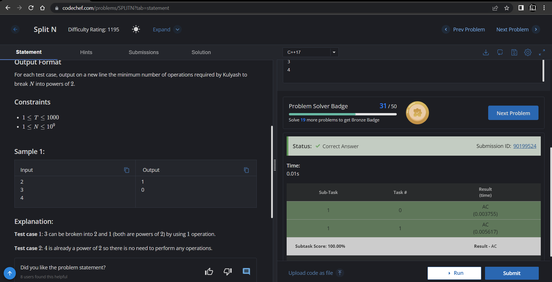

**Understanding about problem:**

Note: If you can't understand the problem, feel free to contact us and we'll help you. Please don't copy and paste from anywhere.

ALL THE BEST

Team CP Club